

University of Petroleum &

Energy Studies

# SCHOOL OF COMPUTER SCIENCE

**Name**: Akshat Agarwal **Course**: BTech CSE **SAP ID**: 500118953

**BATCH**: 1

**PRESENTED TO**: Dr. Syed Sajid Hussain

**Semester**: 3

# Experiment 16: To understand the concepts of Trigger.

**Objective:** Students will be able to implement the concept of trigger.

1. Using implicit cursor update the salary by an increase of 10% for all the records in EMPLOYEES table, and finally display how many records have been updated. If no records exist display the message “No Change”. Creating STUDENT Table:

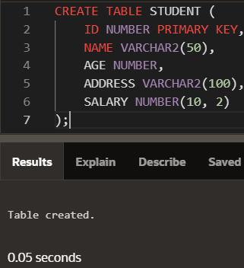

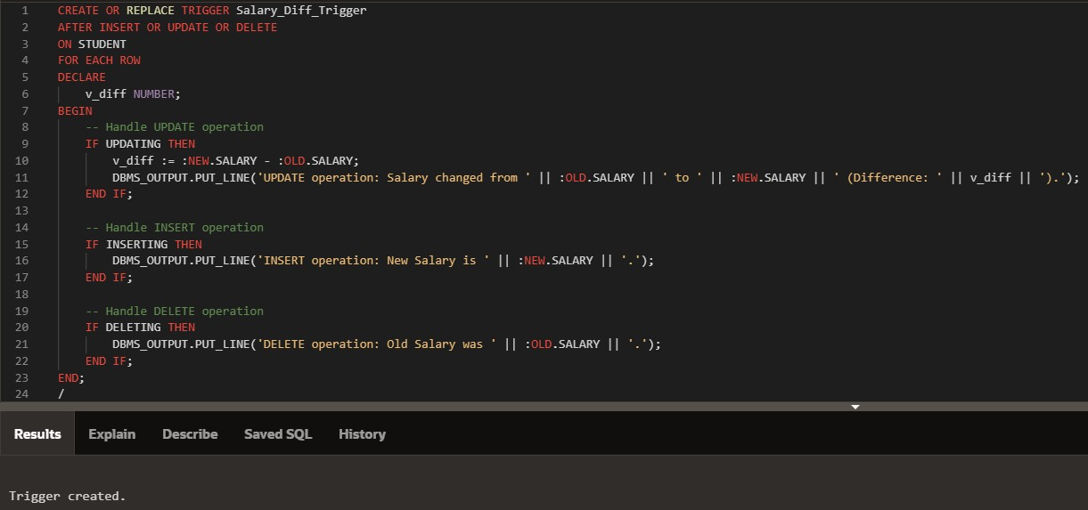INPUT:

OUTPUT:

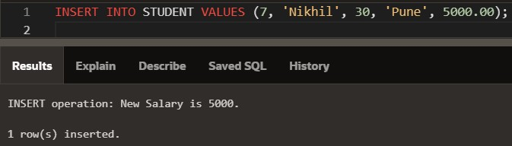Inserting:

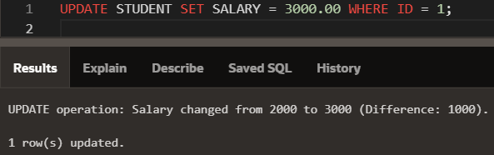Updating:

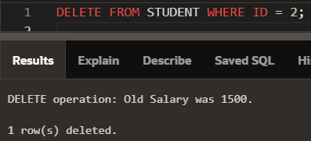Deleting: